Fishy Food Tour Coincides with Growing GMO Labeling Movement
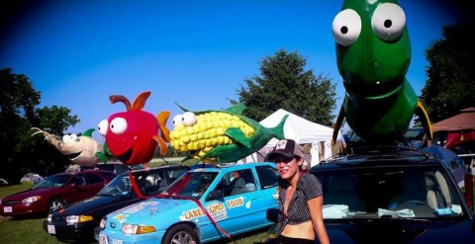
Last Monday saw the official kickoff of a 3,000-mile, cross-country tour to call for labeling of genetically modified foods. The “Are We Eating Fishy Food Summer 2013 Tour” begins in the District of Columbia, and passes through 12 points including Chicago, Kansas City and Denver to reach its final destination in Seattle. Expect rallies, press conferences, and street parties along the way.
The tour is part of a growing movement calling for the labeling of genetically modified organisms (GMOs); and, in particular, genetically modified foods. Currently, the Food and Drug Administration (FDA) does not require such labeling, maintaining that there is no “material” difference between natural and genetically modified foods.
Activists beg to differ. The Center for Food Safety, a national nonprofit environmental advocacy group, states that “The FDA must move into the new century and give consumers the information they overwhelmingly believe to be important for a host of health, environmental, ethical and religious reasons.”
In an episode of the Dr. Oz show dedicated to exploring the GMO debate, both sides were so heated that they could not be invited to the stage at the same time. While some scientists agree with the FDA that GMOs are not materially different from other foods, other scientists find evidence of allergies, increased exposure to pesticides, and even drastic imbalances to natural ecosystems.
One trend is for sure. More and more people are calling for labeling of GMOs. Currently, 64 nations enforce so-called “right to know” laws, while the U.S. continues to lag behind. While activists were disappointed that a move to require labeling recently failed in California, nonetheless, nearly half of all states require labeling of genetically modified foods.
Members of the Fishy Food Tour, however, will only be satisfied when there is a national mandatory label requirement in place. To learn more about the tour and to participate in stops along the way, visit the tour website.

